C2R RECEIPT

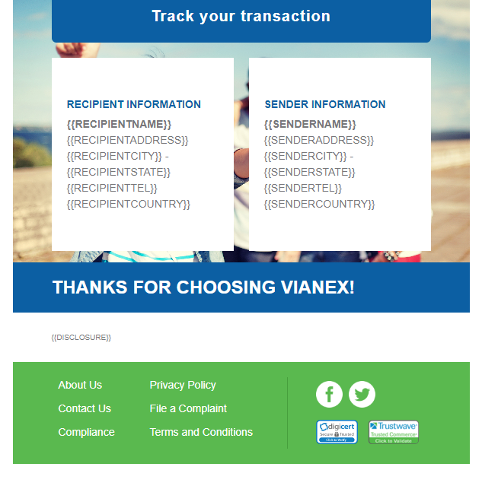

Disclosure – editable contents are pending from client

Footer – links are found on the sample HTML



About Us –

Contact Us

Compliance- Privacy Policy

File a Complaint –

Terms and Conditions -

FB

Twitter